//DOCUMENTARY / PHOTOJOURNALISM / CURATORIAL //

VICENTE JAIME VILLAFRANCA

Unit 1510 Pioneer Pointe, Brgy Highway Hills, Mandaluyong City, Philippines 1550
Mobile: +639088894474
Email: vjvillafranca@gmail.com ; www.veejayvillafranca.com

OBJECTIVE

 | - | For general reference
EDUCATION

 | - | 2000-2005 Bachelor of Fine Arts and Design Major in Advertising Arts. Royal Pontifical University of Santo Tomas.
 | - | 2005 Angkor photo festival – workshop for young Asian journalists with mentors Sarah Caron (Cosmos Paris), Patrick Chauvel (Paris Match) and  Antoinne D’ Agatta (Magnum Photos)
 | - | 2007 – Full scholar at the Asian Center for Journalism Diploma in  Photojournalism course under the World Press Photo Foundation and Konrad Adenaeur Foundation.

WORK EXPERIENCE

- 2003 – 2006 staff photojournalist. Philippine Graphic weekly news magazine.
- 2005 – 2006 staff photojournalist BusinessMirror newspaper
- Assigned in the Presidential beat in 2003. Became a regular member of The Presidential Photojournalists Association of the Philippines after 6 months.
- Assigned to the regular news beat after one year and a half in the Presidential beat covering hard news, business and feature stories.
- Covered the ongoing insurgency in Southern Philippines mainly in Basilan, Cotabato, Jolo and Zamboanga.
- Started a documentary project on the ethnic people Badjao in Southern Philippines.

- 2003 – 2011 - On-call stringer for Agence France-Presse, Associated Press.
- 2006 – 2010 - stringer of Thomson-Reuters news agency Manila Bureau.
- 2005 – 2007 -Manila correspondent World Picture News (WPN) New York USA.
- 2007 – 2013 - stringer for United Nations IRIN photo department.
- 2006 – 2011 - Co-founder of D&FT (Design & Fotografie Team) design agency specializing in advertising photography, print and industrial designs.
- 2008 – present -Manila correspondent exclusively for
Getty Images Global Assignments n 2008 – 2010 - Vice – Chairman and head of educational and training committee – Philippine Center for
Photojournalism
n 2010 – present – represented by Asia Motion agency in Cambodia and France
n 2013 – present – correspondent for Bloomberg News

CLIENTS
Aid agencies: United Nations World Food Programme,
UNICEF, Save the Children Philippines and UK, Marie
Stopes International, OXFAM, United Nations News
Service, Peace and Equity Foundation, AECID
Philippines, GTZ German cooperation, Embassies of
Germany, Netherlands, Spain, United Kingdom, and Australia, IOM, UN FAO, Greenpeace International, Save the Children and USAID.
Publications: The Philippines Graphic, Philippine
Daily Inquirer, Neon and Stern (Germany), Sunday
Times Magazine (UK), British Journal of Photography
(UK), Private Magazine Online and Le Monde (France),
Getty Images UK(editorial), The International Herald Tribune, Time magazine, Svensa Dagbladet (Sweden), Newsweek Magazine, Newsweek online.
EXHIBITIONS

Getty Images Gallery London August 2008 – Marked: Gangs of Baseco
Woo gallery Vilnius, Lithuania October 2008 – Marked: Gangs of Baseco
National Museum of the Philippines May 2008 – Marked: Gangs of Baseco
Oarhouse gallery November 2008 – Myanmar ravaged by Cyclone Nargis
Penguin gallery 2008 – Marked: Gangs of Baseco
Kabuhi exhibition Hongkong November 2009 – Marked: Gangs of Baseco (single print)
CubaoX June 2009 – ‘Creatures of habit’ daily life in the Philippine National Railways
Getty Images Gallery London August 2009 – A race divided:
Illegal Burmese migrants in India

Phnom Pehn Photo Festival December 2009 – Marked: Gangs of Baseco & Burmese migrants in India (slideshow)
Silverlens Photography Gallery February 2010- Marked: Gangs of Baseco

Antennes-photo July 10 2010 Rencontres d’Arles festival – Marked: Gangs of Baseco

CYAN Studios – Oslo, Norway – March 2011 - Marked: Gangs of Baseco

Metropolitan Museum – Manila, Philippines – May – July 2011 - Marked: Gangs of Baseco and Faith above fate.

Blanc compound – Manila, Philippines – October 2011 – Faith above Fate
Sagamihara city gallery – Sagamihara, Japan – October-November
2011 – A race divided: Illegal Burmese migrants in India
Nikon salon gallery – Tokyo, Japan – January 2012 – A race divided: Illegal Burmese migrants in India
Nikon salon gallery – Tokyo, Japan – May 2012 - Silent
Emergency: Battling malnutrition in the Philippines
JIV Gallery – Manila, Philippines – June 2012 – Faith above fate
National Library – Manila, Philippines – July 2012 –
Protagonistats AECID in cooperation with the Spanish government inaugurated by Her Majesty Queen Sofia of Spain.
IPA Gallery- Singapore – September 2012 – Displaced Earth: Climate Refugees in the Philippines
Ayala Museum – Manila – November 2012 – Connectados exhibit with Spanish Embassy
Antara Gallery – Jakarta, Indonesia – January 2013 – Displaced Earth: Climate refugees in the Philippines
Metropolitan Museum – Manila, Philippines – September 2011 – Signos
Chiang Mai Documentary Arts Festival – Chiang Mai, Thailand – February 2013 - Displaced Earth: Climate refugees in the Philippines
Metropolitan Museum – Philippines – The Philippine
Contemporary exhibit – 2 prints loaned for the semi-permanent collection of the Banko Sentral ng Pilipinas and Met Museum – February 2013
Gallery Anna – Philippines – CON/TEXT group show – 4 x 6 feet print – Faith above fate – February 2013
The Art Prints Alley – Philippines – Fearless group show – 5 prints from Displaced Earth project – May 2013
The Climate Imperative – Philippines- Eastwood mall - 30 prints from Displaced Earth project – June 2013

P-Noise – Denmark – Images from photographer’s portfolio – 10 prints – September 2013
Manila Art showcase/ Vmeme – Philippines – mixed portfolio on print and lightboxes – September 2013

Pineapple Lab, Manila, Philippines – July 2015 – Signos
Alliance François Manila – October 2105 – Signos
Vargas Museum, Philippines – October 2015 – Signos
World Humanitarian Summit Peru – May 2016 - Signos
VETRO Gallery Manila – July 2016 – Signos
SUWON Photo Festival Korea – November 2016 – Signos and
Burmese migrant project
Ceritera – Kuala Lumpur Malaysia – June 2017 - Signos
Metropolitan Museum – Seascapes exhibition – June 2017 – Signos
Art Fair Philippines – Provocations – March 2018 - Signos
2018– 2023 shows currently being updated but available upon request.
BOOKS

- “Malabrigo lighthouse project” – a coffee table book aimed to save the lighthouse from the Spanish era located south of Manila endangered of being demolished.
- “Corazon Aquino Tribute” – published by ABS-CBN, this book project pays tribute to the late president and democracy icon.
- The MERCY Project “Inochi”- published by Mado-sha in Japan and produced by James Whitlow-Delano.
- NEXT#03 – World Press Photo Foundation-
Showcasing the works of 12 up and coming visual reporters after completing the coveted Joop Swart Masterclass Program.
- SIGNOS – published by MAPA books and designed by Teun
van Heidjen. This is the culmination of a 6-year visual investigation on the lives of communities affected by the

 |  | adverse effects of climate change.
 | - | Future Cities – Published by USAID SURGE Photobook project 2021
AWARDS & CITATIONS
- 1st Prize winner – Newsbreak and British Embassy Muslim photo contest 2007.
- 1st Prize winner – European Union and Phil. Center for Photojournalism photo contest on UNDP funded projects 2005.
- Honorable Mention – World Bank photo contest 2006.
- Ian Parry Scholarship foundation - print exhibited 2007.
- Nominated for National Geographic All Roads documentary program 2008 and 2010.
- 2008 - awardee of the Ian Parry grant, London, United Kingdom. The first Asian to bag the prestigious award that supports up and coming photographers to produce their personal projects. Documentary project “Marked: Gangs of Baseco” exhibited in Getty Gallery in London, UK
- Grantee of the 2nd Crossing Point residency program during the 20th anniversary of the Visa Pour l’image photojournalism festival in Perpignan, France in 2008.
- Honorable mention in European Union’s climate change photo contest with his essay on ‘Monsoon nights’ in 2010.
- Grand winner - Asian Photo Prize Sagamihara Photo Festival 2011 Sagamihara, Japan.
- One of the 12 recipients of the 2013 Joop Swart Masterclass program in Amsterdam, Netherlands.
- Save the Children media awards 2015 – Reportage on malnutrition in Mindanao 1st place
- Invisible Photographr Asia Photobook prize of the year – 2018.
- World Press Photo 2021 Digital Storytelling Video of the year nominee with Director Joanna Arong
REFERENCES
 |  |  | - | Can be furnished upon request. For published work, please refer to the attached tearsheets.
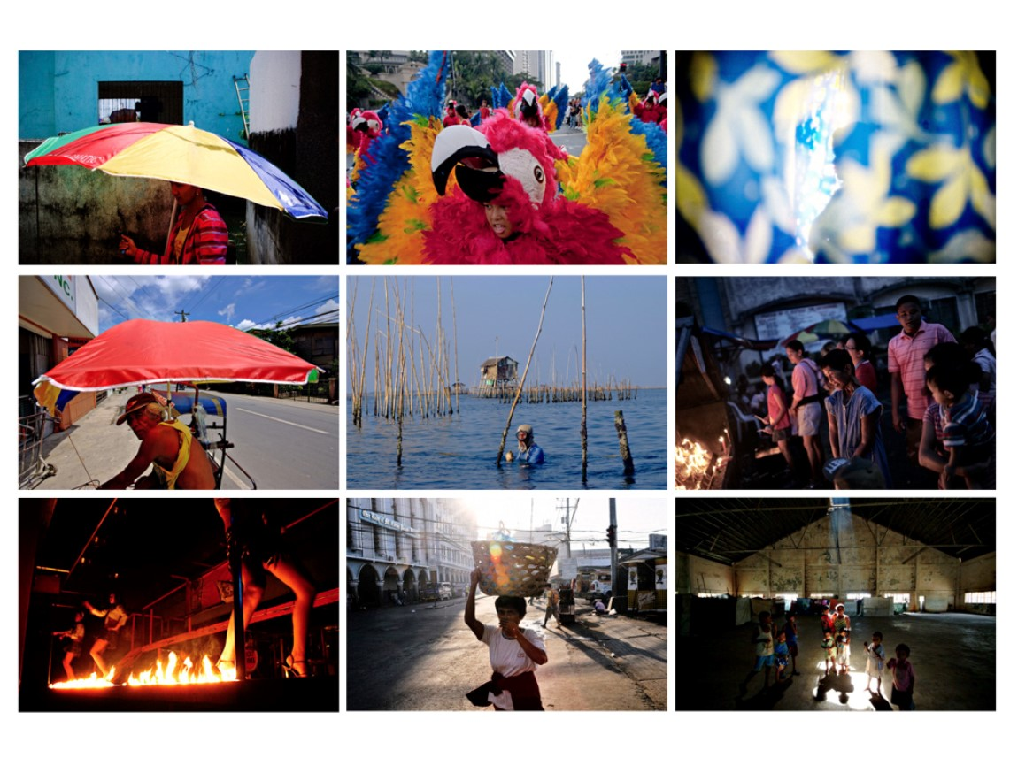

Prepared by:

Vicente Jaime “Veejay” Villafranca
Photographer
+639088894474
vjvillafranca@gmail.com
www.veejayvillafranca.com

